**Addition Reaction**: These reactions occur by the formation of rapid formation of rapid chains and no elimination of small molecules occur. Such reactions generally occur among double or triple-bonded molecules, or oxo-ring compounds. Addition reactions can be further of three types—

i. Step Reactions

ii. Chain Reactions

iii. Ionic Reations

i .Step Reactions: In step reactions, a π bond is broken and two new σ bonds are formed. The substrate of an electrophilic addition reaction must have a double bond or triple bond. ii .Chain Reactions : In chain addition reactions, the polymer is formed in a single step and within the fraction of a second. The chain kinetics occur in 4 steps – Initiation, Propagation, Transfer and Termination. *Variations of Chain Addition Reaction :* If we consider ‘M’ and ‘N’ be two monomeric species, then the chain addition reaction can be of the following types – **Homopolymerization** If only M and N are present,

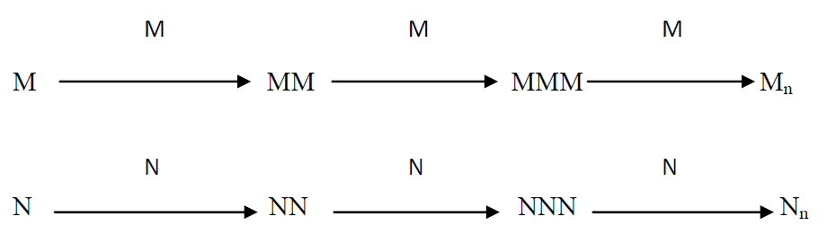

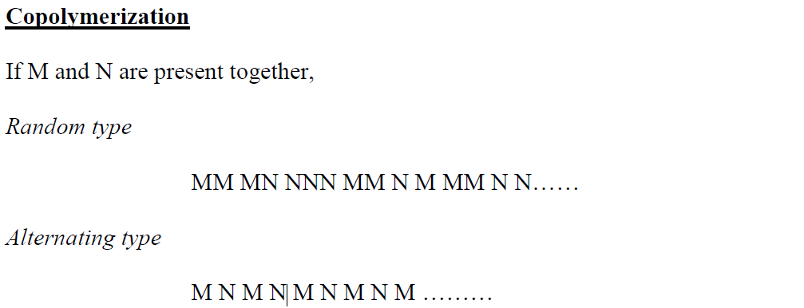

**Block Polymerization** In this type, multimers resulting from straight polymerization coupled together in blocks.



**Graft Polymerization** These have a structure which differs from block polymers ; and are formed from M and N multimers



In Graft polymerization, β – or X - radiation or chemically reactive functional groups ensue the formation of reactive radicals on the main chain or on the grafted section. Reaction Kinetics : Let, A – radical source

B – monomer molecule

*- activated Bm , B n – growing monomer molecule chain of lengths ‘m’ and ‘n’. X – any solvent , impurity, etc. which can act as transferable energy species.

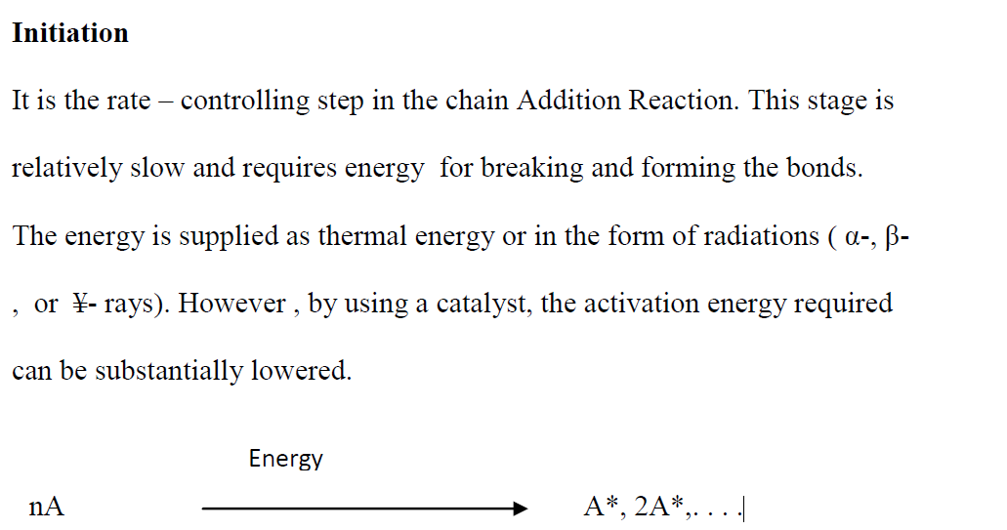

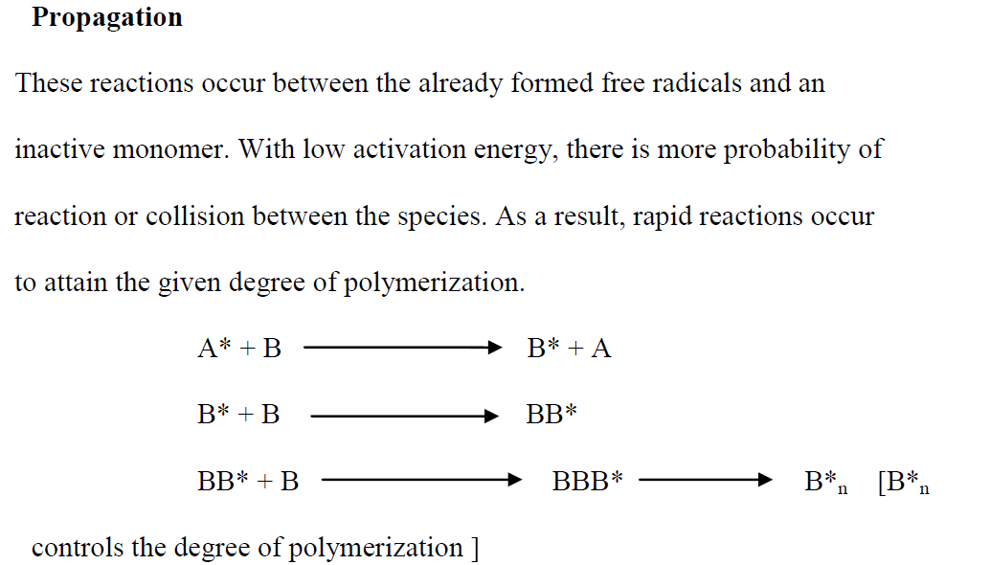

**Chain Transfer Reaction** In this reaction , one radical of the multiplying chain terminates and without the loss of any number of free radicals, a new chain begins. These reactions control the degree of polymerization and the rate of branching of the polymers.

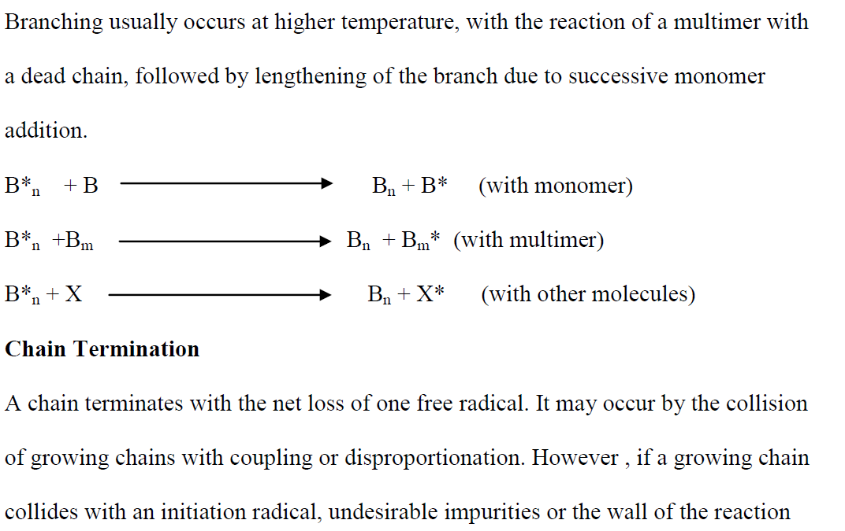

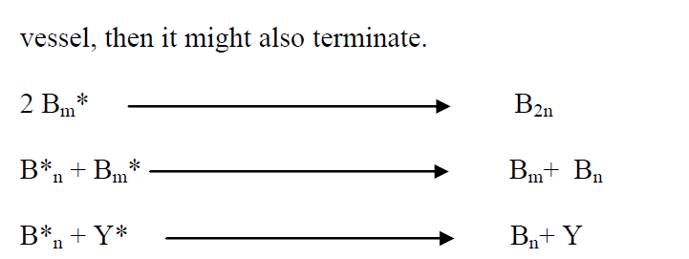

iii .Ionic Reaction : These are similar to chain addition reaction with free radicals , however ; instead of neutral, unpaired electrons, they have a positive or negative charge. A co-catalyst may be used, which is usually a trace of H2O, which is necessary to produce ionization, as the reaction cannot occur in absolute dry conditions. An example of ionic addition reaction is the preparation of polyisobutylene with boron trifluoride catalyst.

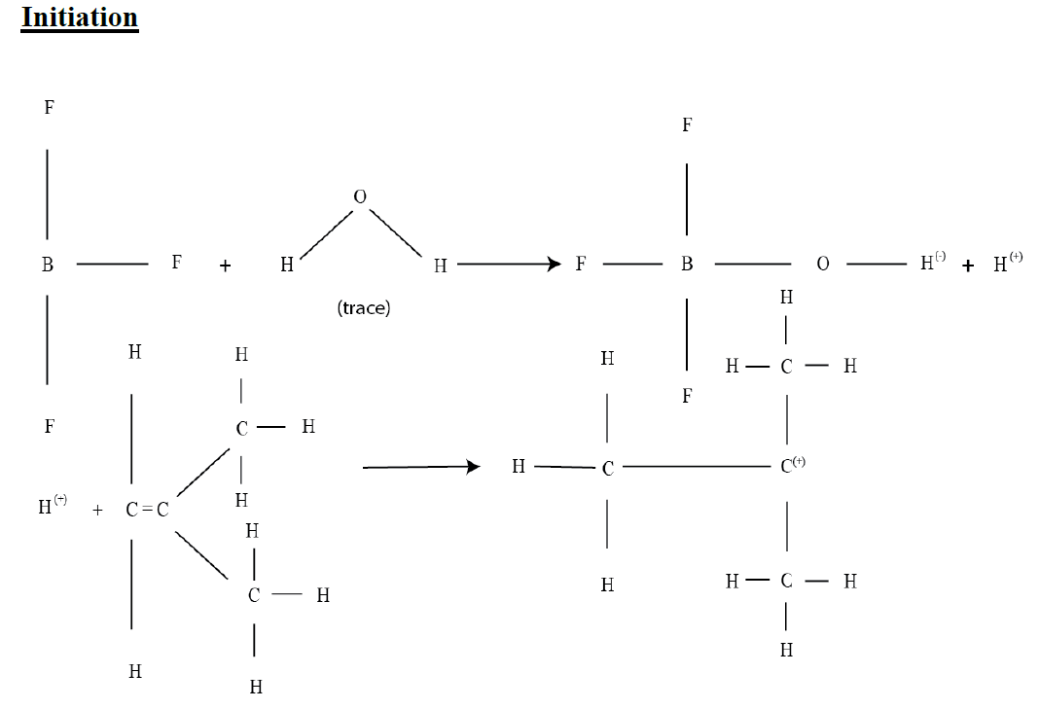

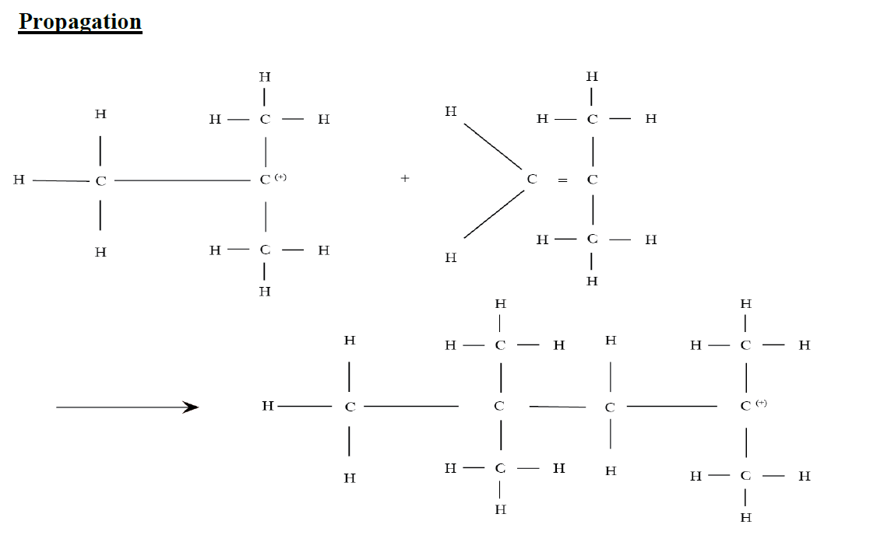

**Termination**

